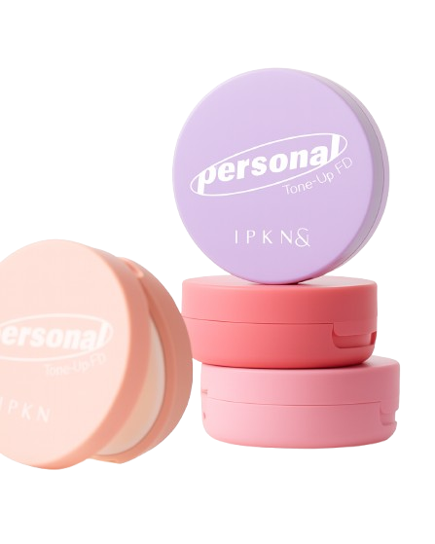
Name : Personal cushion blusher
Description :
A radiant cushion blusher that boosts vitality, giving you a 100% idol- like glow.
Direction :
At the final step of your base makeup , take an appropriate amount onto a puff and gently pat it around the cheeks.

